**SIMULATION AND MODELLING**

Key Performance Indicators define factors the institution needs to benchmark and monitor. Assessment techniques provide the mechanism for measuring and evaluating the defined factors to evaluate progress or impact. KPIs specify what is measured and assessment techniques detail how and when it will be measured. KPI is a measure used to define and evaluate how successful an organization is. Typically is expressed in terms of making progress towards its long-term organizational goals. KPI incorporates information on the sources, calculations and definitions for each measure and sets out the timetable for submission of monthly data.

KPIs are quantifiable measurements that reflect the critical success factors of a business.

Key Drivers that have a major impact on the performance of the business

A handful of numbers that give the owner an “at a glance”view of the business

Keep their finger on the pulse of the business

Identify hot spots that need attention

Act quickly to drive the business forward

**Structure of The Simulation**

You are an engineering manager in charge of a service center where customers arrive to the center with an arrival rate α = 30 customer/hr. As shown in below figure, the service center has parallel 3 service stations each with a service rate µ = 12 customer/hr. Both inter-arrival and service times are exponential.

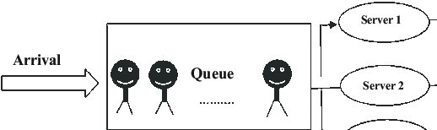

As an Engineering Manager of the service center, you decided to use the following five key performance measures (KPIs) are:

* Avg. customer waiting time (Wq)
* Avg. time a customer spends in the service center (W)
* Avg. number of customers waiting in the queue (Lq)
* Avg. number of customers in the service center (L)
* Avg. server utilization (U)

**Model**

